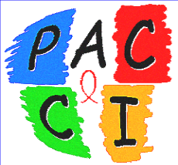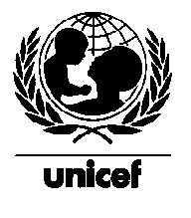

Report

UNICEF Interim Project, Abidjan 1998-1999

Transition Phase between a Research Project (ANRS 049a Trial)
and a Public Health Programme
in the Prevention of the HIV-1 Transmission
Abidjan, Côte d'Ivoire

January 2000

Msellati P ^{1,2}, Hingst G ³, Kaba F ⁴, Viho I ², Welffens Ekra C ⁵, Dabis F ^{2,6}

1 Institut de Recherche pour le Développement, Abidjan, Côte d’Ivoire
2 Projet DITRAME, programme PAC-CI, Abidjan
3 UNICEF Côte d’Ivoire, Abidjan
4 Programme National de Lutte contre le SIDA/MST/TUB de Côte d’Ivoire, Abidjan
5 CHU de Yopougon, Abidjan
6 Unité INSERM 330, Bordeaux, France


Correspondance et demande d’exemplaires : Dr Msellati Philippe, IRD, Centre de Sciences Sociales, 04 BP 293, Abidjan 04, Côte d’Ivoire,
fax 00 225 35 40 15, mel : msellati@ird.ci

Table of Contents
Summary 3
1. Introduction 5
2. HIV counselling and testing for Pregnant Women, AZT Treatment for HIV+ Pregnant Women 5
2.1 Continuation of Counselling and HIV Testing Proposal in Four Health Centres of Abidjan 5
2.2 Continuation of Distribution of Short AZT Maternal Treatment 16
2.3 Infant Feeding for infants born to HIV+ Mothers 19
2.4 Specific Problem: Screening Test 21
3. Strengthening Political Commitment and Developing Technical Skills in the Reduction of Mother-to-Child HIV Transmission of HIV 23
3.1 Developing a Training Manual 23
3.2 Developing the content of a training for trainers 23
3.3 In service-training for staff 23
3.4 Developing Advocacy Messages and Conducting Advocacy Meetings with Health Personnel and Community Leaders 24
4. Future Outlook 24
5. Conclusions 25
Bibliography 28

UNICEF Interim Project, Abidjan 1998-1999

Executive Summary

In order to continue the field work realised in the context of a clinical trial on prevention of mother-to-child transmission (PMTCT) of HIV (ANRS 049 trial, DITRAME Project) in Abidjan, Côte d’Ivoire, the investigators of the DITRAME clinical trial, the UNICEF Office in Côte d’Ivoire and the National AIDS Programme of Côte d’Ivoire, jointly, developped and implement a six month interim-project.

Methods

The project team offered HIV Counselling and Testing on a routine basis by the project team in four health centres in Abidjan. Zidovudine peri-partum treatment was offered to HIV positive women, together with alternatives to breast feeding. Subsequently, field training was given to health care providers and a technical guide was elaborated, material for training sessions and feasibility protocol were subsequently developed in French for this kind of programme.

Results

Among the 4,309 pregnant women attending their first antenatal care visit from October 1st, 1998 to April 15th 1999, 198 left the health centre before the counselling session, 355 could have neither the counselling nor the HIV test proposal because of a language barrier and 3,756 benefited from individual counselling and pre-test session (87.2%). 3,452 women agreed to the HIV test (91.9% of the women who received the counselling). HIV prevalence was 12.95% overall (445 HIV+ women) and 5% among young women under the age of 18. 2,384 women returned for their HIV test results (69.1% of the women who were tested). Among the 2,998 HIV negative women, 2,116 (71%) returned and among the 445 HIV+ women, only 268 (60%).

Overall, 63.5% of the women to whom the HIV test was proposed agreed to do it and returned for their results, this represents the global acceptability of the counselling and testing in the programme. This result was obtained without any incentive or transportation fees offered. 144 HIV+ women informed about their HIV+ result and about the possible intervention for PTMCT did not return for the treatment.

From October 1998 to August 1999, 122 HIV+ women met the team and 100 HIV+ pregnant women received by Zidovudine: 20 did not come back after the beginning of the treatment, 77 women, who received the Zidovudine prophylaxis, gave birth to 78 live neonates. At six weeks of life, 36 children born to HIV+ women, were breastfed, (46% of the infants followed by the programme), two received mixed-feeding and 41 (52%) were artificially fed. Mothers, choosing to feed artificially their infants, encountered difficulties to avoid breastfeeding without disclosing their HIV status. For some of them, mixed feeding was a coping strategy allowing the introduction of alternatives to breast-feeding in the family.

Four work sessions were conducted with the whole project team on: pre-test and post-test counselling, development of the tools kit necessary for training and supervision of counsellors. Other training sessions allowed the elaboration of a counselling guide. Last, a workshop was organised on caregivers/patients relations and burn-out. 16 midwives, a social worker and a nutritionist were trained. Back in their routine activities, without the help of the project team, they were able to provide a limited number of HIV test proposals, for reasons not clearly identified so far.

Comments

The UNICEF Interim Project, first operational programme for PTMCT of HIV in Côte d’Ivoire, provided number of useful insights for planning and implementing future public health programmes in this field.

HIV test is feasible under good conditions in antenatal care units and is well accepted by pregnant women. In the community, at least around this programme, there is a demand for accessible voluntary HIV testing. Even if we still do not know how to measure the impact of voluntary counselling and testing, the pre- and post-test counselling allowed informing more than two thousands of women in 6 months on HIV and AIDS and disclosing their HIV serological status to them. Secondly, a significant number of young women, under 18, are already HIV infected in Abidjan. A specific approach to the prevention of HIV and family planning is necessary for this population group. Thirdly, the return for results can still be improved, in particular among HIV+ women who would benefit directly and should be actively involved in the subsequent PMTCT Programme.

It seems very difficult to propose that counselling and HIV testing of pregnant women can be done without any additional staff in ANC. Counselling and testing requires, even perhaps more than other activities, a close supervision and a high involvement of health workers and decision-makers.

In the urban context of Abidjan, it is feasible to develop alternatives to breastfeeding for HIV+ women with well organised support. The project had been designed to adhere to the reality of the routine antenatal and post natal care. However, in future PMTCT programme, it is necessary to pay special attention to an active follow-up of children artificially fedand to provide the clinical, nutritional and social support to the mother and child.

It is imperative to develop advocacy strategies concerning PMTCT of HIV targetting the decision-makers in the heakth services and the health workers if we want to integrate this new activity in their routine ANC activities.

Conclusion

The UNICEF Interim Project is the basis for implementing the UNICEF pilot programme on the reduction of MTCT of HIV in Côte d’Ivoire which should start in early 2000. A specific effort to develop training materials is going to be made and will constitute the basis for training sessions for Ivorian health professionals and, possibly, for French-speaking health professionals in other African countries.

1. Introduction

The cessation of enrolment in the DITRAME ANRS 049a trial and the analysis of the results in the following months showed a 37% reduction in mother-to-child transmission of HIV-1 at the age of 6 months with a short maternal regimen of Zidovudine (AZT) (1). The DITRAME Project was conducted in Abidjan (Côte d’Ivoire) and Bobo-Dioulasso (Burkina Faso); it was financed by ANRS and the French Ministry of Cooperation under the PAC-CI Research Programme. The DITRAME Project, the Ivorian National AIDS Control Programme (NACP) and the UNICEF Country Office in Côte d’Ivoire signed an agreement on a 6-month intervention programme beginning 1 October 1998.

The two objectives of this programme, called UNICEF Interim Project, were as follows:

- Pursue the services provided to the target population of the DITRAME Project on routine basis: proposing HIV screening to all pregnant women, pre-test and post-test interviews, counselling, AZT short regimen for HIV+ pregnant women and provision of alternatives to breastfeeding;

- Strengthen political commitment and develop technical skills for reducing Mother-to-Child transmission of HIV in Abidjan.

After conducting corresponding activities from October 1998 to April 1999 and with an additional six-month break needed for monitoring short-term activities initiated and the analysis of the initial findings, we can present the following results which were organised in accordance with the objectives and activities of the UNICEF Interim Project.

2. Counselling and HIV creening for pegnant wmen, AZT teatment of HIV+ pegnant Women

2.1 Continuation of Counselling and HIV Screening Proposal in Four Health Centres of Abidjan

a) Context

The UNICEF Interim Project pursued the HIV test proposal for pregnant women in the four health centres where the DITRAME Research Programme had been carried out. These were antenatal care units (ANC) in the Yopougon Teaching Hospital (CHU), the Yopougon Urban Health Centre (FSUY), public sector health structure, and the Community-based Health Centres of Yopougon Ouassakara (FSUc OUA) and Anonkoua-Kouté (FSUc AK) (this latter health facility is in fact located in the Abobo dstrict, a neighbouring dstrict of Yopougon). HIV testing was systematically proposed to pregnant women attending these facilities since December 1994 (CHU), February 1995 (FSUY), April 1997 (FSUc AK) and September 1997 (FSUc OUA) respectively (2). The populations of pregnant women attending these centres come from varied sociological backgrounds. The CHU mainly caters for middle-class women, the two Yopougon Health Centres (FSUY and FSUc OUA) by low-income lower-class urban women and the FSUc AK, located in a village and not in the city, caters for a “semi-rural” population.

b) Conditions for Conducting Counselling

In October 1998, the UNICEF Interim Project took over the ANRS 049 trial without any change in personnel with the exception of one doctor who had been recently transferred upcountry. The team therefore comprised 5 counsellors (1 social assistant and 4 other health workers) 2 midwives and 2 doctors who had been conducting these activities for several years under the DITRAME Project, on a paid contract basis (see Staff List provided in the annex). Apart from one midwife, none of the staff was officially assigned to these health centres by the Ministry of Health or any other organisation. The activities were carried out in the premises of the DITRAME Programme and were linked to the regular activities of this ongoing research programme, ensuring the long-term follow-up of mothers and children.

The HIV Screening Test was proposed to the subject during individual pre-test interview given at the first antenatal consultation after examination by the staff. This individual pre-test counselling lasted 10 to 15 minutes on the average. The test was done free of charge as well as all the activities of the UNICEF Interim Project. The only information gathered was the name and forename of the woman, her age and the number of weeks of pregnancy. An identification number was assigned to her in order that the entire process would remain anonymous following this initial stage. In contrast to the previous period, during the therapeutic trialno age limit was set to the test proposal and girls below eighteen years received counselling as well as the test proposal. Proposing the test to very young girls did not entail any special problem. The test was readily accepted and did not raise any difficulties in terms of consent or confidentiality in this still limited experience. There was also no limitation on the childbearing age beyond which the test could not be proposed.

Once a number was assigned to women who had agreed to be tested, blood sample w taken. The HIV diagnostic strategy which was used in this project was the following: all the sera were tested with two Elisa tests (Ice MurexTM and VironostikaTM). Following the recommendations of the Mother-to-Child Unit of the NACP, discriminatory tests between HIV-1 and HIV-2 were not used in this algorithm. The results therefore corresponded to an HIV infection without additional specification. The corroborating negative tests yielded a negative result. The corroborating positive tests yielded a positive result but in disclosing the result, a fresh sample was taken from the subject for similar testing in order to avoid possible errors. If the findings of the two initial tests did not tally, a second sample was requested from the woman one month later and tested using the same algorithm.

The result of the test was available two weeks following the date of taking the sample. The result was given to the woman at an individual post test counselling session by the same counsellor who had proposed the test. The duration of the post test session varied particularly according to the result given. In particular, a post-test session for an uninfected woman could last on the average 10 minutes. For an HIV+ woman, the post test interview lasted on the average 30 minutes.

If the woman was uninfected by HIV, she was given further prevention counselling and advised to bring her partner along for a similar test to be carried out. She subsequently returned to the routine antenatal consultations.

If the woman was HIV-infected (HIV+), she also received preventive counselling and was advised to inform her partner. If the latter consented, he was then tested under similar conditions, that is, free of charge. Furthermore, specific counselling was given to HIV+ woman on the means available for reducing the risk of infecting her child, the associations of people living with HIV, various places in the city where, as a person living with HIV, she could obtain care, assistance and counselling. Lastly, she was given an appointment in the week with the project member responsible for the follow-up of HIV+ persons (anaemia testing, AZT prescription, choice of feeding, ...).

When HIV+ women who had been informed of their status attended the HIV follow-up appointment, generally one week after the disclosure of the result, specific counselling on the reduction of Mother-to-Child Transmission (MTCT) was provided them, and the haemoglobin rate was measured. The haemoglobin rate, the level below which it was not possible to prescribe AZT, was 7g/dl haemoglobin. A schedule was defined for the planned interventions: starting date of AZT administration and appointment date for the tolerance consultation (one week after the initial administration). If at the latter date, the observance and understanding of the treatment were favourable, a 3-week AZT treatment was prescribed and the patient given an appointment for consultation after the delivery of her baby. The two AZT pills to be taken at home at the beginning of labour were given to her and the procedure to be followed was explained in detail. As in the research project, this way of taking the medication during delivery was adopted to avert the possible stigmatisation of HIV+ women during their contact with the health personnel in the centres where they were going to deliver. If the women had chosen for artificial feeding prior to delivery, she received a tin of milk powder before delivery to cover the time lapse between birth and her first post-partum contact with the programme. If the woman had still not delivered after one month of treatment, she was advised to return to the project site for another 2-week supply of AZT.

The treatment proposed consisted of one 300 mg of AZT morning and night from the 1st day of the 36th week of pregnancy to delivery, which is the treatment adopted for Côte d’Ivoire by the Mother-Child Unit of the NACP for the prevention of the MTCT of HIV. Furthermore, two additional 300 mg AZT capsules were given to the woman at the consultation for treatment to be taken at the beginning of labour and before going to the maternity for delivery. The DITRAME Project systematically offered daily prophylaxis for anaemia (generic iron-folates) from the first day of the preventive treatment of MTCT until delivery.

It was not possible under the UNICEF Interim Project to cater for the full medical care of HIV+ women who were receiving AZT as was the case previously. Fide infected women who were aware of their status, the support provided by the UNICEF Interim Project consisted of free supplies of Zidovudine and artificial milk, if the women chose alternative their child, which was a major innovation as compared with the previous situation.

c) Description of the Population of Pregnant Women Attending ANC

Out of the 4309 women seen in first antenatal consultation in the four clinics where the UNICEF Interim Project was being implemented, 4,11 were seen by members of the team during the period from 1 October 1998 to 15 April 1999 and 198 returned The median age of the one seen was 23 years (rangfrom12 to 48 years, 1st quartile 19 years, 3rd quartile 28 years, N=4,082). Chart 1 describes i detail the distribution by age of this population.

Analysis by project site shows, as in the trial itself, that women attending the CHU were older (29 years in median, from 17 to 44 years, N= 155) than those attending the other health facilities (23 years in median, from 12 to 48 years, N=3927).

Twenty-six pregnant girls below 15 years (0.6%) attended for their first ANC visit ; 1089 with ages ranging from 15 to 19 years, representing 26.6% of the sample. In total, 475 girls (11.6% of patients) below 18 years of age, and therefore minors, were enrolled in this programme.

Chart 1
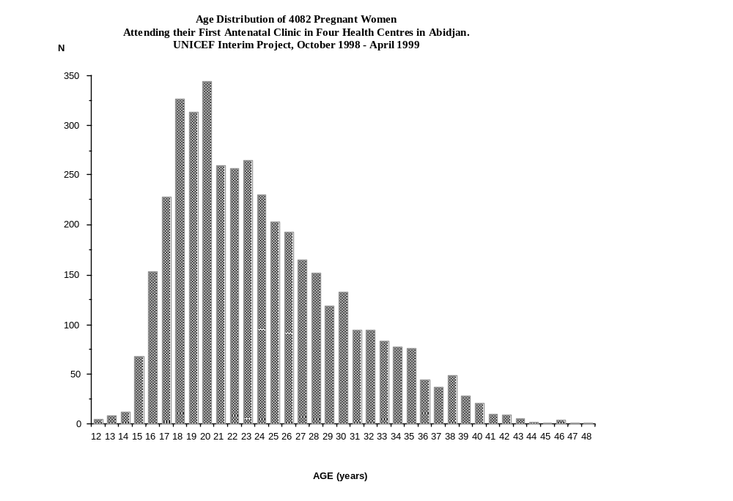

The median gestational age of women attending for their first ANC visit who were seen by a team member was 25 weeks of amenorrhoea (from 4 to 40 weeks of amenorrhoea, 1st quartile 20, 3rd quartile 28). The analysis by site indicates that women attending the CHU come for their first ANC visit earlier in their pregnancy than women from other sites (median of 21 weeks, N= 153 25 weeks, N=3820).

Chart 2 shows the detailed distribution of weeks of pregnancy of this population. Considering that at least one week is required between the first ANC when the test is proposed and the beginning of the treatment by AZT if necessary, it is 98.8% of first ANCs visits which fall within this category.

Chart 2
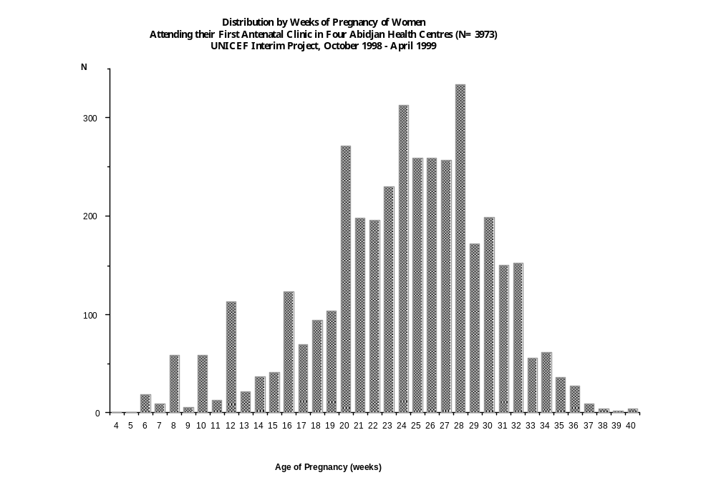

Table 1 describes the activities of the various sites involved in the UNICEF Interim Project during its six months of implementation. The total number of ANCs as well as the number of new ANC were calculated on the basis of entries in midwives’ registers on the sites. The teams only received 95% of such women attending their first ANCs, essentially because some women managed to leave the health centre immediately after their consultation without passing through the room where HIV test was proposed.

Table 1: Screening Activities for Pregnant Women in Four Health Centres in Abidjan
UNICEF Interim Project, October 1998 - April 1999

Place | Total Number of ANCs | New ANCs | Women received by the Project | Tests proposed  (TP) | Tests accepted  (TA) | TA/TP  % | Return for result (RR) | RR/TA  % | RR/TP  %
CHU | 657 | 209 | 155 | 155 | 142 | 91.6 | 127 | 89.44 | 81.9
FSUY | 4783 | 1300 | 1210 | 1129 | 1115 | 98.7 | 858 | 76.95 | 76.0
FSUc OUA | 5645 | 1400 | 1367 | 1207 | 1132 | 93.8 | 801 | 70.75 | 66.4
FSUc AK | 5536 | 1400 | 1379 | 1265 | 1063 | 84.0 | 598 | 56.26 | 47.3
Total | 16621 | 4309 | 4111 | 3756 | 3452 | 91.9 | 2384 | 69.06 | 63.5
ANC Antenatal Clinic, TA/TP Test acceptance rate, RR/TA: Rate of return for result, RR/TP global acceptability rate

Overall, 3756 screening tests were proposed to pregnant women free of charge from October 1998 to mid-April 1999 in the four ANCs, representing 91.4% of women seen by the project and 87.2% of new ANCs. Out of the women to whom the test was proposed, 3,52, that is 91.9% accepted it. 2,384 returned to find out their results, a rate of return of 69.1%.

The product of these two components, namely acceptance rate and return rate, represents the global acceptability which is 63.5%. This means that 63.5% of women to whom the HIV test was proposed agreed to it and returned for their results.

355 women representing 8.5% of women seen by the team did not receive the pre-test counselling and test proposal due to a language barrier between them and the caregivers during the individual interview. These were essentially language problems (More or Hausa languages in particular). Usually such persons were accompanied to the health centres by family members who served as interpreters and intermediaries. Since the pre-test or post-test interviews were on an individual basis and HIV, they could not be conducted in the presence of an intermediary. A concrete case unfortunately recently confirmed the significance of this rule. Upon the insistence of a Mossi patient, servntest was proposedto her sister-in-law. The sister-in-law received counselling, translated it to the pregnant woman and agreed that the latter should be tested. When the result was released, it was not possible to convey it through the sister-in-law. This resulted in a complex situation where it became necessary to find a health worker who spoke More, was acceptable to the woman and who was sufficiently discreet. These women who received neither counselling nor testing were comparable in age and gestational age at the time of their first ANC to those who did.

Out of the 3452 women tested for HIV, 2,91 were uninfected (HIV-), 445 were infected (HIV+) ; it was not possible under the poject to distinguish the type of HIV involved, and 16 were of an undetermined status. HIV prevalence was therefore 12.95%, which is similar to what had been observed in the same population in previous years (2), as well as an uncorrelated anonymous study on Abidjan (3).

Table 1 also shows that over a period of six months, 3756 pregnant women from two Abidjan districts received at least one individual counselling sn HIV, its mode of contamination and the means of protection. This accounts for 10% of the total number of women delivering in Abidjan over the same period since it is estimated that there are 78,000 deliveries per year in the city. Out of these 3,756 prenant women, 2,384 (635%) received information on HIV on two occasions, first during the test proposal and a second time on the disclosure of the result. This fact needs to be taken into account in a global information approach on HIV and the control of the spread of the epidemic even if we are not yet in a position to measure the effect of this information on the eventual prevention behaviours of persons aware of their HIV status.

An already noted trend in Rwanda (4) and in this programme (2) also appears in this roject. Fewer Hnfected women returned to find out their results than uninfected women. Sixty percent of the 445 HIV+ women and seventy-one percent of the 2,991HIV- women came back for their results (p<10-5). A qualitative study carried out among the same population had indicated that the non-return for results was significantly rated to the fear by women of being infected and the inability to manage such a situation (5). Initially, the women agreed to be tested as part of the health care provided for their pregnancy. Then they returned home, thought about the consequences (supposed or real) of a possible HIV infection, discussed the issue in their social circles (friends, family members or partners) and did not return for their results. They overestimated the risk of infection since a significant proportion of uninfected women did not return either for the same reason. It is noteworthy that a negligible number of pregnant women attending the clinics knew their HIV status prior to the test.

These observations on the selective return of women for their results have an obvious implication for future intervention programmes. However, the women directly concerned by the complete intervention (VCT and AZT) tend more often not to get involved. Further research will have to be carried out in this area.

We were able to analyse the HIV test proposal data covering the same period and the same sites for the previous year e (October 1997-March 1998) for the sake of comparison (Table 2).

Table 2: Screening ctivities among pegnant wmen in fur Abidjan
ealth cs durg a refeece period DITRAME Project, October 1997 - March 1998

Place | Number of ANCs | 24-32 Weeks pregnancy | New  ANCs | Tests  Proposed  (TP) | Tests  Accepted  (TA) | TA/TP  % | Return for result | RR/TA  % | RR/TP  %
CHU | 263 | 90 | 90 | 82 | 41 | 50% | 41 | 100 | 50.0
FSU | 6137 | 2631 | 1945 | 1392 | 1350 | 97% | 1341 | 99.3 | 96.0
FSU Ouassa | 6161 | 3193 | 2040 | 1526 | 1321 | 86.6% | 1080 | 81.8 | 70.8
FSU AK | 6419 | 2558 | 1566 | 938 | 677 | 72.2% | 610 | 90.1 | 65.0
Total | 18980 | 8472 | 5641 | 3938 | 3389 | 86.0% | 3072 | 90.6 | 78.0%
ANC Antenatal Clinic, TA/TP Test acceptance rate, RR/TA: Rate of return for result, RR/TP global acceptability rate

A comparison of the two periods (Tables 1 and 2) shows that acceptance of the test improved during the implementation of the UNICEF Interim Project. This improvement which has in fact been sustained since the beginning of activities testifies to a better acceptance of the test by the population and the significant role played by the staff in proposing it. The rate of return for results was higher during the trial but it is to be noted that the 69% attained by the UNICEF Interim Project is good and is being maintained despite the lack of any material incentives. Indeed, during the trial period, women received transportation allowance to help them return for the results. The amount involved was modest (CFAF 500, less than US$1) but it was not necessarily negligible for these women mostly from poor backgrounds.

Table 3 shows HIV prevalence by age group (excluding 16 undetermined results). In some cases, the numbers by age groups were low and therefore the prevalence observed needed to be treated with caution particularly for girls below 15 years and women aged 35 years and over. Women aged between 25 and 34 are those who are most often infected by the HIV. Important is to note that HIV prevalence among pregnant women below 18 years is high and alarming (21 out of 411, 5.1%).

Table 3: HIV Prevalence among regnant wmen by ae goup in fur Abidjan Health Centres
UNICEF Interim Project, October 1998 - April 1999
Age Group | Number of HIV+ Pregnant Women  Pregnant Women (%) (IC at 95%)
Under 15 years | 2/15 (13.3%) | (0-30%)
15-19 years | 63/903 (7.0%) | (5.3-8.7%)
20-24 years | 165/1149 (14.4%) | (12.4-16.4%)
2529 years | 120/718 (16.7%) | (14.0-19.4%)
30-34 years | 65/398 (16.3%) | (12.7-19.9%)
35-39 years | 22/187 (12.4%) | (7.7%-17.1%)
>39 years | 8/66 (12.1%) | (8.1-20%)
Total | 445/3436 (12.9%) | (11.8-14%)
CI: Confidence Interval

d) Other Tests

Table 4 indicates the number of HIV tests carried out among other people than pregnant women resulting from voluntary requests by individuals or couples in the four centres during the six months of the Project. These tests were conducted because the service had been put in place by the Ditrame Project and maintained by the UNICEF Interim Project at a time when there was no other service of this kind in the Yopougon District.

Table 4: Number of Tests Carried Out among Persons Other than Pregnant Women in Four Health Centres of Abidjan
UNICEF Interim Project, October 1998 - April 1999
Health Centre | Number of Husbands Tested | Other Persons | Number of Pregnant Women Tested
CHU | 6 | 0 | 142
FSU Y | 16 | 16 | 1115
FSUc OUA | 7 | 8 | 1132
FSUc AK | 14 | 10 | 1063
TOTAL | 41 | 34 | 3452

For comparison, we gathered similar data covering the same duration for the previous year when this was the Ditrame Research Project. During those six months, 3389 tests were conducted for pregnant women and 22 husbands of pregnant women who had come to be tested, 11 children of infected women and 10 unpregnant women. Therefore the number of partners tested doubled and 13 additional tests were carried out for other persons (couples and young people) but generally this activity is relatively marginal. On occasions, the UNICEF Interim Project sites were therefore used by the neighbouring community as confidential and free testing centres. The figures presented are low. However, there is a clear impression, which needs to be confirmed, that a new demand for testing is emerging in the population around the centres where HIV test proposals are made for pregnant women. The end of 1998 and the beginning of 1999 were marked by a new demand for testing by couples (although the women were not pregnant) and non-pregnant young women and men unaccompanied by pregnant women. At this stage, it is difficult to know the causes of these changes in behaviour. Several reasons could account for this: knowledge of this testing centre which used to be the DITRAME Centre for the Yopougon and Abobo areas, change in attitudes towards HIV testing, impact of the UNAIDS initiative annount access to anti-retroviral treatment and the results of the Mother-to-Child transmission prevention trials.

Similarly, it is to be noted that for the first time since 1994, the rate of acceptance at the CHU of Yopougon of the HIV test exceeded 90% whereas previously this was below 60% (Tables 1 and 2). Indeed in this specific population, the rate of acceptance of the test had always remained relatively low whereas the rate of return for results had been higher than 75% since the beginning. It is possible that women attending the CHU clinic who are from the middle-class and are generally better informed about HIV are also more sensitive now to the need to undergo HIV testing during pregnancy and have consequently become more receptive than before to HIV test proposals. This comes in the wake of the Conference on AIDS in Africa held in Abidjan in 1997, the dissemination of initial information on the efficacy of short antenatal treatment and the beginning of the UNAIDS initiative on access to anti-retroviral treatment.

On the following page, we present four charts on the distribution by age of populations attending ANCs for the first time, reception of test proposals and their acceptance and HIV infection. These charts show clearly that the distribution by age group is comparable for women with regard to ANC attendance, test proposal and its acceptance. For the distribution by age of HIV+ women, pregnant women aged between 20 and 24 years account for nearly 40% of HIV+ women.

Chart 3

Distribution by ge of pegnant wmen atending ANCs
for the 1st Time in our halth cntres in Abidjan
(N=4309)
UNICEF Interim Project, October 1998 – April 1999

Chart 5

Distribution by ge of pegnant wmen having accepted
HIV creening tst in fur halth cntres in Abidjan
(N=3452)
UNICEF Interim Project, October 1998 – April 1999

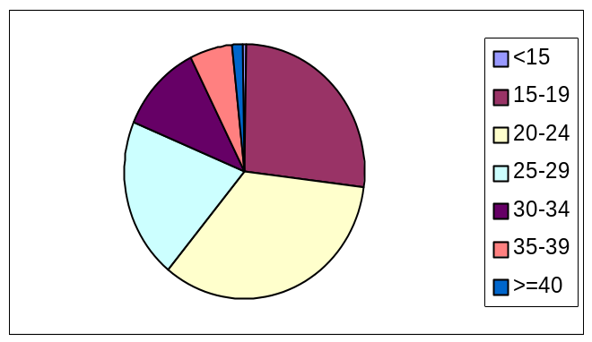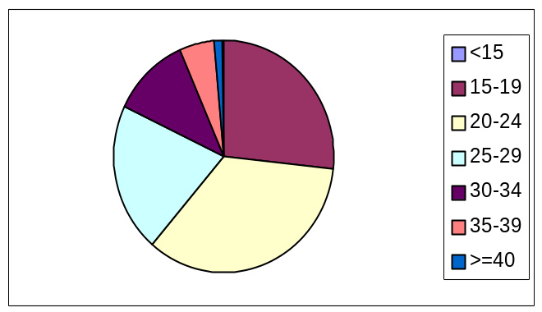

Chart 4

Distribution by Age of regnant wmen having received
HIV Testing Proposal in our halth cntres in Abidjan
(N=3756)
UNICEF Interim Project, October 1998 – April 1999

Chart 6

Distribution by Age of HIV+ regnant wmen
in our halth cntres in Abidjan
(N=445)
UNICEF Interim Project, October 1998 – April 1999

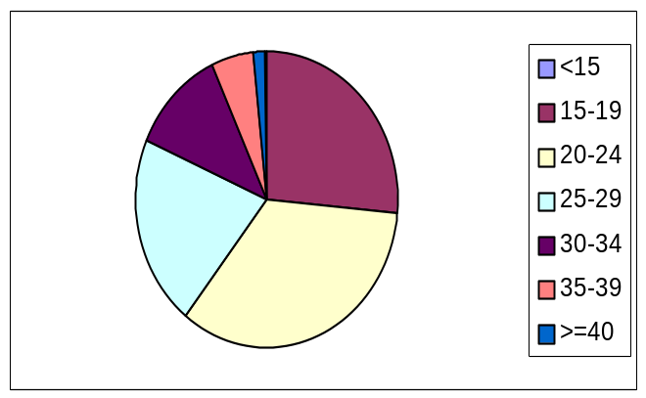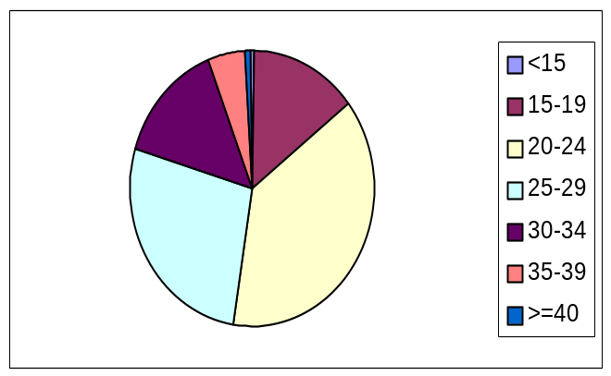

2.2 Continuation of Distribution of Short AZT Maternal Treatment

From October 1998 to August 1999, out of the 445 HIV+ pregnant women, 177 did not come back for their results. Furthermore, 144 other women received their results, post-test counselling and information on the Mother-to-Child Transmission Prevention Programme but did not return for the following stages for unknown reasons. Only 124 HIV+ women informed of their status made contact with the team about the reduction of MTCT of HIV. This corresponds to 27.8% of HIV+ women screened by the Project between October 1998 and April 1999 and 46.3% of HIV+ women who came for their results. It is to be noted that this is similar to the results previously described for the same sites (6).

These 124 HIV+ women using services provided by the UNICEF Interim Project for reducing MTCT had a median age of 25 years (16 to 42 years). Out of these women, 16 did not return for the administration of AZT according to the schedule given them for no obvious reason; two women had a miscarriage between the first contact with the team and the schedule date for the AZT administration, two delivered live neonates before receiving AZT and four women were seen again only after delivery. For the 100 who received AZT, this treatment was initiated at 36 weeks of pregnancy on the average (range 0) as indicated in the protocol. Out of this number who received at least one AZT dose, 20 were not seen again before delivery. They received only part of their AZT regimen from 36 weeks of pregnancy and, for unknown reasons, did not return. 80 women received AZT up to delivery and gave birth to 78 live babies and 3 still-born babies. The average duration of the AZT preventive treatment was in meds (0 to 68 days, standard deviation 15). Chart 7 summariss the follow-up of women under AZT.

Per partum treatment (2300 mg capsules at the beginning of labour) was taken by 61 women and two took 4 capsules, that is 79% of women who should have taken them.

With regard to special cases, two women (out of the 80 managed) did not follow all the pre-partum treatment as planned. After two weeks of treatment, the first of such women did not return for the other capsules due to family constraints. The second one who was expecting twins (probably with inaccurate clinical estimation of delivery time) interrupted her treatment for one month believing that once the first packet was finished it was no longer necessary to return for the others.

124 HIV+ women
Chart : Evolution of Women having received AZT (Zidovudine)Treatment Proposal
for MTCT of HIV
UNICEF Interim Project 1998-1999 Abidjan
Delivery before ZDV= 2
Miscarriage before ZDV= 2
Not seen again after proposal = 16
Start maternal ZDV = 100
Live neonates = 78**
No further news = 20
Still-born = 3
* 4 women were seen again after delivery and did not receive ZDV
** one twin pregnancy
Seen again after delivery* = 4
Delivery = 80
Chart shows the series of events since the first antenatal clinic up to AZT administration under the UNICEF Interim Project. Once again, whereas the number of HIV+ women receiving AZT is low, the total number of pregnant women reached by the Project is high. Advantage could be taken of this contact in order to improve the organisation and content of antenatal clinics.

Chart

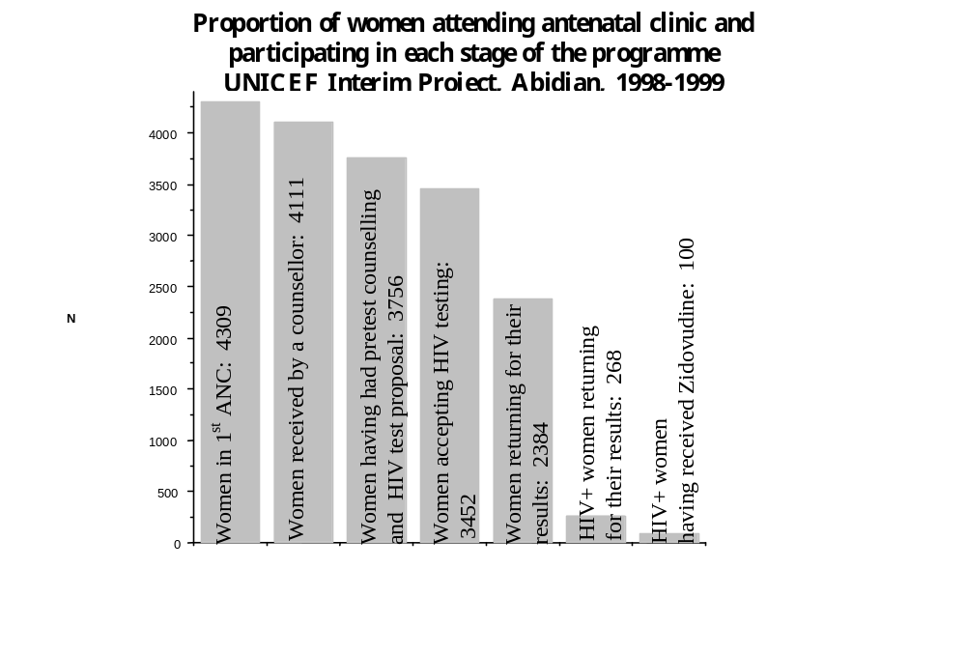

2.3 Feeding of Babies Born to HIV+ Mothers

a) Description of Activities

Under this Project, HIV+ women seen again at least once following the disclosure of their test result received information on the advantages and problems related to the various types of feeding for babies of HIV+ mothers. This was in the form of individual interviews conducted before delivery with the site manager or a counsellor who was a member of HIV association. During such interviews, emphasis was also placed on expected reactions of members of one’s circle where alternatives to breastfeeding were chosen. When the mother decided to use an alternative to breastfeeding (which in Abidjan means baby powder milk), part of the initial interview consisted in assessing her capacity to carry out this feeding successfully. Women were also informed that the artificial milk would be provided freely but in controlled quantities (maximum of two tins at each appointment) and that they would have to fetch them each time accompanied by their child so that he or she can be weighed and examined. Women opting for artificial feeding were given a tin of milk and feeding materials at their last visit prior to delivery to ensure a sufficient quantity of milk to feed their new born babies at the maternity before bringing them to the Project site.

The team gave recommendations on early cessation of breastfeeding to women who had chosen the latter, in line with the guidelines of the DITRAME Project (7).

During the first six months, corresponding to the inclusion phase in the UNICEF Interim Project, artificial milk was prescribed by the Project team. The women then bought milk in pharmacies and were later refunded upon presentation of the receipts. In April 1999, a supply of milk was bought by the Project, stocked and managed by the Project pharmacy in the same way as drugs, and the milk was directly distributed by the team to the mothers. We were thus able to stock 500 kgs of milkpwhich we bought from a children’s food manufacture (JammetTM, Montauban, France) who was already known to UNICEF at the global level. It is to be noted that with the payment of customs duties and port handling charges, the price of this milk (FF 16.21) was close to the retail price of ordinary baby milk (FF 17.85) purchased in Abidjan. Furthermore, delivery time was very long. The artificial milk procurement procedure should therefore be revised, taking into account the existence in Abidjan of various manufacturers. This procedure must be considered as a provisional measure pending the direct supply of artificial milk by UNICEF.

In order to monitor the development of children receiving alternatives to breastfeeding, the quantity of milk given did not exceed the quantity needed for one week of baby feeding. Secondly, the presence of the child was required for the issuing of each quantity of milk in order to ensure the weekly monitoring of its clinical and nutritional status. A weight monitoring card was issued and a technical card specifying the number of tins of artificial milk required according to the age of the child was established and distributed to the team members in each centre. Anthropometric and morbidity data will be analysed later. When mothers chose mixed feeding and following discussion within the team of caregivers, the programme did not provide artificial milk since mixed feeding combines the risks related to the two types of feeding according to recent data provided by a study conducted in South Africa (8).

b) Results

The target population was always made up of 124 HIV+ pregnant women informed about their status and consulting the team at least once. The sample comprised the 77 women under treatment who delivered 78 live births, the 2 women who delivered before receiving AZT and the 4 women who had four live births without AZT treatment, totalling 84 live births. As Chart shows, 56 children received breastfeeding after birth, 7 children mixed feeding and 21 children only artificial feeding.

At the age of six weeks, there were five deaths and the 79 living children were fed as follows:
36 on breastfeeding, 2 on mixed feeding and 41 on artificial feeding.

The 22 children on artificial feeding between birth and the 6th week of life were subjected to this type of feeding during the third week of life (from 2 to 35 days). The five deaths that occurred before the 6th week of life, three (birth, 3rd and 4th days of life) on breastfeeding and two (4 and 6 weeks) on artificial feeding were due to neonatal causes (1st week of life) and an unspecified infectious syndrome (6 weeks of life). As the Chart shows, 16 mothers switched from breastfeeding to artificial feeding without a period of mixed feeding.

Some mothers stated that they resorted to mixed feeding right from the birth of their child as a strategy for introducing artificial feeding and preparing the family for an early cessation of breastfeeding (around two months and two and a half months).

One mother had a problem with the packaging of the artificial milk provided by the Project since it was not a brand available on the Abidjan market, thus arousing suspicion in her husband. At least one other woman had a similar stigmatisation problem related to the unknown brand. Another woman who had explained that the doctors asked her not to breastfeed because of insufficient production of breast milk, was forced to leave Abidjan for the village in order to receive traditional treatment for increasing breast milk production. We rejected artificial feeding in one case, that of a mother who wished to give her child artificial feeding but lived at more than 100 kilometres from Abidjan in a locality where clean water was scarce.

Many women used a plastic cup with a beak instead of the feeding bottle, but artificial feeding with the cup recommended by UNICEF was hardly used. Specific training should be provided to the team and other caregivers involved in this area

No specific follow-up was planned beyond the birth of the children born by HIV+ mothers in the UNICEF Interim Project since we hoped for their integration into the normal MCH system. However, as indicated above, and pending a decision by the mother on the type of feeding and early weaning or not, the indispensable precautionary measures associated with the distribution of artificial milk compels us, in view of the absence of postnatal visits or information on the subject, to set up

- An accurate address list of women covered by the Project
- A system of discreet visits implemented with the prior consent of each woman which would also serve to remind her of the need to attend the MCH clinics.

2.4 Specific Problem: Screening Test

For logistic reasons, rapid HIV tests were not used in this operational phase. However, it is essential to develop its use for the pilot phase. The likelihood of having blood test results within a very short time is attractive for persons tested because it will reduce the agony of the waiting period. However, the experience of counselling in the DITRAME Project compels us to be with undertaking counselling, testing and disclosure at the same time. A minimum period of reflection of 24 hours between counselling and testing or between testing and disclosure seems indispensable in order to avoid the pitfalls relating to the lack of adequate preparation of women prior to disclosure.

Chart
Feeding Practices among Children of HIV+ Mothers.
UNICEF Interim Project 1998-1999 Abidjan (N=84*)
Breastfeeding = 56
Mixed Feeding = 7
Artificial Feeding = 21
Birth
N=84
Six Weeks
N=79
Artificial Feeding = 6
Artificial Feeding = 16
Mixed Feeding =1
Artificial Feeding = 41
Mixed Feeding =2
Breastfeeding = 36
* 78 were born of HIV+ mothers having received AZT Treatment at the end of pregnancy.
Deaths =3
Deaths = 2

3. Strengthening Political Commitment and Developing Technical Skills in the tion oher-to-Child HIV Transmission

3.1 Developing a Training Manual and Modules

In October and November 1998, four work sessions for the entire UNICEF Interim Project and DITRAME Project teams were held on the essential training elements for the following activities:

Pre-test counselling for pregnant women
Post-test counselling and disclosure to HIV- pregnant women
Post-test counselling and disclosure to HIV+ pregnant women
Approaches to training counsellors.

Two specific sessions were devoted to a group discussion on the “Guide on the Psychosocial Management of HIV Infection” for the Ivorian NACP in the light of the experience of counsellors of the DITRAME and UNICEF Interim Projects. A World Health Organisation (WHO) document on voluntary counselling and testing for pregnant women (9) was translated into French. A UNAIDS document on HIV and infant feeding is also currently being translated and should be ready at the beginning of the year 2000 (10).

3.2 Developing Training Content for Trainers

Six work sessions for one female counsellor, a midwife, a physician, the UNICEF/Abidjan Health Officer and the Project Coordinator aimed at developing a training manual on the counselling techniques in the area of HIV infection of pregnant women and children born of HIV+ mothers. This handbook is being prepared along the lines of an existing WHO manual “Formation aux techniques de conseil en sexualité, procréation et santé des adolescents” (11) and a training guide prepared by the Togolese National AIDS Control Programme (12).

Lastly, a workshop was held for the team in October 1998 on caregiver/patient relationships and “burn-out”. The latter term describes the state of psychological exhaustion affecting caregivers and social workers when their activities and the effects of the latter fall short of demands and the expectations of their work which they often carry out in difficult conditions (13). A work session was devoted to the problem of disclosing the results of tests on children to the parents and the way of carrying it out. A final meeting discussed issues of family planning for HIV+ women who know their status.

3.3 In service Training for Staff

Fifteen midwives and one social assistant from the Yopougon Attie FSU, a nutritionist from FSU-Com of Anonkoua Koute, the senior midwife from the Ouassakara FSU-Com and a midwife from the Yopougon CHU each spent one week assisting in proposing HIV testing or carrying it out under supervision as well as providing post-test counselling and disclosure to women to whom they had proposed the test. Now back to their routine activities, they have only made a limited number of proposals for various reasons not clearly identified so far. However, the senior midwife of Ouassakara FSU-com has made 10 to 15% of the total number of test proposals since the beginning of the programme. Further, two midwives assigned to the International Therapeutic Solidarity Fund (FSTI) who have taken over the UNICEF Interim Project in two health centres since 15 April, were trained by the site manager who was a member of the UNICEF Interim Project team. This advanced training (two months) enabled these midwives to effectively involve themselves in the FSTI Programme which has now commenced.

3.4 Developing Advocacy Messages and Conducting Advocacy Meetings with Health Personnel and Community Leaders

The Project team participated in two workshops on the prevention of Mother-to-Child Transmission organised in Abidjan in May 1999 by UNAIDS and WHO AFRO. The WHO AFRO Seminar entailed a detailed review of interventions in the area of Mother-to-Child HIV Transmission and was organised for managers of reproductive health/family planning programmes and national AIDS control programmes. The second seminar which was organised by UNAIDS (Geneva) concerned more specifically the monitoring of future pilot programmes.

Two late breakers were presented at the Montreal (14) and Lusaka (15) Conferences in September 1999 on the preliminary results of the UNICEF Interim Project.

A discussion workshop with policy-makers of Côte d'Ivoire is planned for February 2000. A work has to b

4. Future Outlook

A number of issues raised in the UNICEF Interim Project can only be addressed later, notably those relating to the child growth and morbidity and paediatric management. A few issues for reflection and discussion in three areas are outlined below:

- Programme evaluation: a workshop organised by UNAIDS, mentioned above, resulted in the development of simple indicators for assessing the impact of the programme and its operation in the context of the prevention of Mother-to-Child HIV Transmission (16). Some of these indicators are presented in this report. Others will be gathered in the coming months and presented in a specific report on a) their practical assessment as process and result indicators and b) obtaining them routinely, which is crucial for the monitoring and evaluation of operational programmes.

- The growth and morbidity of children particularly in the context of artificial feeding. This will entail the analysis of clinical and anthropometric data gathered on newly-born babies under the UNICEF Interim Project in order to verify, in the presumed context of adequate supervision, whether or not there are difficulties attached to the practice of alternatives to breastfeeding. Secondly, the findings obtained from counselling on short-term breastfeeding should be analysed.

- Lastly, a programme on Mother-to-Child HIV Transmission cannot avoid analysing after one year of life the proportion of children among the children born by HIV+ mothers having received AZT during pregnancy or having or not practised alternatives to breastfeeding.

5. Conclusions

The UNICEF Interim Project, the first operational programme on the prevention of Mother-to-Child Transmission of HIV in Côte d’Ivoire, and probably in West Africa, provided various kinds of useful information. Some of them have wider implications for future African pilot programmes. Others are more specific to the population of Abidjan. Firstly, it is clear that a number of interventions are possible provided a trained and motivated personnel is available.

HIV test is feasible under good conditions in antenatal care units and is well accepted by pregnant women. Even if we still do not know how to measure the impact, in six months the pre- and post-test counselling allowed the team to inform, apart from the intervention on the Mother-to-Child HIV Transmission, thousands of women on HIV/AIDS and their personal serological status.

A significant number of girls below 18 years are infected by HIV and these young women who are particularly vulnerable represent a high proportion of pregnant women. A specific approach for this population is indispensable both in the field of HIV prevention and that of family planning.

Return for results can still be improved particularly for HIV+ women who are directly by the ollow-up to the programme. This rate of return and its corollary, the global acceptability of the test, are indicators of the perception by HIV+ women of the risk of stigmatisation to which they would be exposed by attending projects for the prevention of Mother-to-Child HIV Transmission. Specific studies must be carried out in order to provide a better understanding of this finding and improve the global acceptability of the test.

There appears to be a need at the community level, at least in conjunction with this programme, for better access to HIV testing which could be described as a proximity need which is only partially filled by the current structures in Abidjan.

It will be difficult to envisage testing and counselling among pregnant women without increasing the number of the personnel who is already involved in antenatal care in view of the time-consuming nature of this activity. The latter requires, perhaps more than other health actions, regular supervision and the full commitment of the staff, those in charge of their supervision and the decision-makers.

In the specific urban context of Abidjan, it is possible to introduce alternatives to breastfeeding for HIV+ women given the appropriate support. The acceptance of alternatives to breastfeeding in the first weeks of life exceeded our expectations in terms of the number of women interested. There is a need for training on exclusive feeding practices and alternatives to breastfeeding which are only partially covered both at the theoretical (reference books, training modules, etc.) and practical levels, essentially due to lack of experience.

The UNICEF Interim Project was designed to reflect as much as possible the real situation of pregnant women and the normal postnatal follow-up in Abidjan. However, it is important that in such programmes an active follow-up system be developed, apart from teams capable of carrying out counselling and testing, both for the future of children of HIV+ mothers who received AZT during pregnancy and for the alternatives to breastfeeding. This active follow-up may not be possible without a system of home visits.

It is necessary to involve the managers of other relevant activities in maternal and child health and integrate the prevention of Mother-to-Child Transmission of HIV into these other programmes (reproductive health/family planning, National Child Health Programme). This is yet to be carried out in Abidjan.

Lastly, the UNICEF Interim Project was originally designed as an intermediate stage to a wider programme. In Abidjan, the gradual establishment of the International Therapeutic Solidarity Fund ensured that there was no interruption in counselling and testing in the health structures concerned. Following the UNICEF Interim Project, the UNICEF pilot programme will begin in Abidjan in a2000 All these experiences are essential for the gradual introduction of a national policy on the prevention of Mother-to-Child Transmission of HIV in Côte d’Ivoire.

Acknowledgement

The authors of this report would like to thank the Representative of UNICEF/Abidjan, M.C. Dalais, Directors of the National AIDS Control Programme, the STDs and Tuberculosis in Côte d’Ivoire, Dr. I.M. Coulibaly and Dr A Sanogo, Dr. E. Mercier from UNICEF/New York without whose support this project could not have been possible. We also thank the Managers of relevant health structures as well as their staff. Lastly, our thanks go to all the field teams who carried out the day-to-day tasks of this work.

This project was financed by UNICEF. The National AIDS Research Agency also provided financing for the staff and resources of the DITRAME Project.

Bibliography

- Dabis F., Msellati P., Méda N. et al. Six month efficacy, tolerance and acceptability of a short regimen of oral zidovudine in reducing vertical transmission of HIV in breast-fed children: A double-blind placebo controlled multicentre trial, ANRS 049a, Côte d’Ivoire and Burkina Faso. Lancet 1999; 353: 786-92.
- Cartoux M., Msellati P., Meda N. et al. Attitude of pregnant women toward HIV testing in West Africa: Abidjan, Côte d'Ivoire, and Bobo-Dioulasso, Burkina Faso. AIDS 1998; 12: 2337-44.
- Sylla-Koko F., Anglaret X., Traore-Anaky M. et al. Séroprévalence de l'infection par le HIV dans les consultations prénatales d'Abidjan, Côte d'Ivoire 1995. Med Mal Infect 1997; 27: 1-2.
- Ladner J., Leroy V., Msellati P. et al. Factors associated with failure to return for HIV post-test counselling in pregnant women: Kigali, (Rwanda), 1992-1993. AIDS 1996; 10: 69-75
- Coulibaly D., Msellati P., Dedy S., Welffens-Ekra C., Dabis F. Attitudes et comportements des femmes enceintes face au dépistage du HIV à Abidjan (Côte d'Ivoire) en 1995 et 1996. Raisons du refus du test et indifference face aux résultats. Santé 1998; 8: 234 - 8.
- Msellati P., Ramon R., Viho I. et al. Prevention of mother-to-child transmission of HIV in Africa: uptake of pregnant women in clinical trial, Abidjan, Côte d'Ivoire. AIDS 1998. 12: 1257-8.
- Msellati P., Meda N., Welffens-Ekra C., Leroy V., Van de Perre P., Mandelbrot L., Dabis F. for the ANRS 049 trial group. Zidovudine and reduction of HIV vertical transmission in Africa. Am J Public Health 1999. 89: 946-7.
- Coutsodis A., Pillay K., Spooner E., Kuhn L., Coovadia H.M. for the South African Vitamin A Study Group. Influence of infant-feeding patterns on early mother-to-child transmission of HIV-1 in Durban, South Africa: a prospective cohort study. Lancet 1999 354: 471-6.
- Baggaley R. & van Praag E. Voluntary counselling and testing for HIV infection in antenatal care: A practical guide. WHO Geneva, draft, November 1998. Traduit par P. Msellati et G. Hingst. Conseil et dépistage volontaire pour l’infection du HIV dans les soins prénatals: guide pratique. Abidjan mars 1999: 27p.
- UNAIDS, UNICEF and WHO. HIV and Infant Feeding. Volume 1: Guidelines for decision-makers; Volume 2 A guide for health care managers and supervisors; volume 3 A review of HIV transmission through breastfeeding. 1998.
- Programme de Santé des adolescents. Division de la santé de la famille. Organisation Mondiale de la Santé. Formation aux techniques de conseil en sexualité, procréation et santé des adolescents. Guide de l’animateur. Genève, Suisse, Août 1993. WHO/ADH/93.3. 179 p.
- Programme National de Lutte contre le AIDS/STD du Togo. Guide du conseiller psycho-social en matière de HIV/AIDS. Novembre 1996. Lomé, 100p.
- Collignon R. Nécessité et Difficultés d’instaurer un espace d’écoute pour faire accéder l’indicible au dire. In R. Collignon, M.E. Gruenais, L. Vidal. L’annonce de la séropositivité au HIV en Afrique. Psychopathologie Africaine 1994; XXVI n° 2: 283- 91.
- Welffens-Ekra C., Hingst G., Msellati P. et al. A pilot programme of reduction of HIV transmission from mother to infants in Abidjan, Côte d'Ivoire, 1998-1999. The second conference on Global strategies for the prevention of HIV transmission from mothers to infants. September 1-6, 1999, Montréal, Canada. Abstract 097.
- Msellati P., Hingst G., Kaba F. et al. Un programme de réduction de la transmission mère-enfant du HIV par de l’AZT à Abidjan, Côte d’Ivoire. Mise en place d’une phase opérationnelle 1998-1999. Late Breaker session.
- UNICEF, UNAIDS, WHO. Local monitoring and evaluation of the integrated prevention of mother-to-child HIV transmission in low-income countries. Second draft, April 1999. 115p.

Annex

UNICEF Interim Project

List of Project Staff

Project Officers
Prof. F. Dabis, DITRAME Coordinator, Senior Investigator
Ms. F. Kaba, Project Monitoring Officer for the National AIDS Control Programme
Dr. G. Hingst, UNICEF Project Monitoring Officer
Dr. P. Msellati, DITRAME Coordinator for Abidjan
Prof. C. Welffens-Ekra, DITRAME Senior Investigator

UNICEF Interim Project Staff
Ms. B. Brehe (Social Assistant)
Ms. G. Kissiédou (Counsellor)
Ms. M. Kone (Counsellor)
Ms. C. Zadi (Counsellor)

DITRAME Project Staff
Dr. I. Viho (Clinical Trial Monitor)
Dr. N. Elenga (Pediatrician)
Dr. R. Likikouët (Gynecologist)
Ms. H. Aka Dago Akribi (Psychologist)
Ms. A. Yao (Midwife)
Ms. P. Kassi (Midwife)
Ms. S. Djapi (Counsellor)
Ms. D. Yapi (Social Assistant)
Mr. J. Tanoh (Messenger)
Ms. M. Konan (Pharmacy Assistant)
Ms J N’Goran (gestion)

CEDRES Staff
Dr. P. Combe, Director
Dr. T. Ouassa

